Lab 3 Prelab

**Name**:

**Lab Partner Name (if you worked together and are submitting the same document or mostly the same answers):**

**Lab Section**:

**Submit your prelab document as a PDF file in Canvas under the corresponding prelab assignment. Every student submits their own prelab. Lab partners are allowed to work on the prelab together and submit the same document (if there is actual collaboration on the document). For full credit, the prelab must be submitted prior to the start of lab. Text responses should be typed or printed neatly. You can draw a sketch by hand, or you can use a drawing tool. Try to have started a rough draft of the prelab when you come to class on Tuesday.**

1. System sketch

Similar to the system sketch you did in Lab 1, sketch a diagram that shows how the four push buttons connect to the microcontroller. Your diagram should show the port and the pin (or bit) number of the port that each button is connected to. Give the port name and pin numbers used in the microcontroller. The microcontroller package pin numbers (1-64) are different than the port pin names (e.g, Port A pin 0, PA0). Use the following resources as needed: (1) in-class notes (**see mtg06-notes-concepts-GPIO.pdf**), (2) CyBot board schematics and GPIO pin usage, (3) button.c code, and (4) Tiva datasheet. As part of your sketch, indicate the port and bit of the port that each button is connected to.

1. Data register for a GPIO port

The GPIO port connected to the push buttons is associated with a specific GPIO data register. Answer these questions for the actual port used with the push buttons.

1. What is the specific name of the data register as given in the Tiva TM4C Datasheet (shown in all capital letters)?

Hint: see the List of Registers in the Table of Contents, or open the Table of Contents in the sidebar. Excerpts shown below.

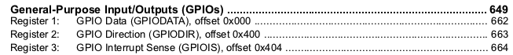

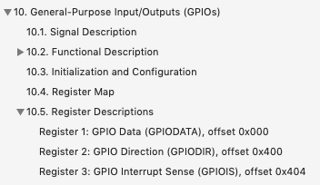

1. What is the specific name of the data register as given by the #define macro in the header file, tm4c123gh6pm.h (TM4C123GH6PM Register Definitions)?

Hint: search for “GPIO registers” in the file, ignore the AHB version (if you find it), ignore the “DATA_BITS_R” name, the 32-bit memory address should start with “0x4…”

1. What is the 32-bit memory address of the data register (in hex)?